System Requirements Statement (SRS)

Car-Pooling

|  |  |  |
| --- | --- | --- |
| Index | Content | Page no. |
| 1 | Introduction | 3 |
| 2 | Functional Requirements | 4 |
| 3 | User Module | 5 |
| 4 | Driver Module | 8 |
| 5 | Passenger Module | 10 |
| 6 | Admin Module | 12 |
| 7 | User Case Diagram | 13 |

# Introduction

This document explains the system requirements and scope for developing a car-pooling System.

Car-pooling System is divided into four main parts: User Module, Driver Module, Passenger module and Admin module.

# Functional Requirements

The Account part of the Car-Pooling System has three modules which are divided into 24 processes described below.

|  |  |  |
| --- | --- | --- |
| No | BRS Requirement ID | Description |
| 2.1 | User Module | |
| 2.1.1 | F1 | SignUp |
| 2.1.2 | F2 | Login |
| 2.1.3 | F3 | Password Management |
| 2.1.4 | F4 | Update Profile |
| 2.1.5 | F5 | History |
| 2.1.6 | F6 | Support and Help |
|  |  |  |
| 2.2 | Driver Module | |
| 2.2.1 | F7 | Ride Creation |
| 2.2.1 | F8 | Edit Ride |
| 2.2.1 | F9 | Cancel Ride |
| 2.2.2 | F10 | View Passenger Booking |
| 2.2.2 | F11 | Accept or Reject Booking Request |
| 2.2.3 | F12 | ViewRatings and Feedback |
| 2.2.3 | F13 | Give Rating and Feedback |
| 2.2.3 | F14 | Trip History |
|  |  |  |
| 2.3 Passenger Module | | |
| 2.3.1 | F15 | Ride Booking and Management |
| 2.3.2 | F16 | Cancel Ride Booking |
| 2.3.4 | F18 | Booking Confirmation |
| 2.3.5 | F19 | ViewRatings and Feedback |
| 2.3.6 | F20 | Give Rating and Feedback |
| 2.3.7 | F21 | Trip History |
|  |  |  |
| 2.4 Admin Module | | |
| 2.4.1 | F22 | User Management |
| 2.4.2 | F23 | Ride Management |
| 2.4.3 | F24 | Reporting and Analytics |

1. USER MODULE :
   1. SIGN UP / USER REGISTRATION :

* Whenever a user enters for the first time, if the user is not registered so they can view a website to become a user he/she has to register through sign up.
  1. SIGN UP SECTION :
* They have to enter the below details to successfully sign up.

1 Email

2. Password

3. Confirm Password

4. Full Name

5. Mobile

6. Address

7. Gender

8. Driving License no.

9. Aadhar Card no.

10. Photograph

* In the first page the user has to enter his email Id password and confirm password and OTP for sign up.
* After successfully adding email id password and confirm password , users move to the next part where more details have to be added. Those are Full Name ,Mobile ,Address ,Gender ,photo, Aadhar card & Driving License.
* In the above all the fields are mandatory except driving license(for passenger module DL is not compulsory).
  1. VALIDATION :
* Email ID is verified using OTP while signing up.
* Passwords must contain one special character, one capital letter and one number.
* After successful registration of the user a user ID is generated.
* So whenever a user login user has to enter the same email Id and password.
* This all field details are passed to the database

3.4 LOG IN :

* In the login page the user has to enter Email Id and password.
* In Login Page Three buttons are there one button for Login, one button for forgot password and other for signup
* If user enter a valid details for login he will be successfully logged in Website, so user can publish or book a ride
* If the user presses the sign up button he will go to the sign up page.
* If a user clicks the forgot password he will go to specific forgot password Section

3.5 PASSWORD MANAGEMENT :

* This section's objective is to handle forgetting password change password.
* If the user selects the forget password, the user has to enter his email Id.
* Once user has entered email id successfully it get compared with database and Password is sent to user email ID
* If details entered by the user are wrong then a straight away error message is thrown below the login button.

3.6 UPDATE PROFILE :

* In update profile section the attributes which are entered during registration time
* Aadhar Card and driving license once entered cannot be changed.
* In update account password there is one more link to change the password
* In the change password section the user has to enter the old password, then new password and confirm the new password.
* If driving license details are entered at the time of a registration then the user can publish a ride as well as he can book a ride.
* If the user has not entered any driving license details at the time of a registration then he can only book a ride.
* If the user updates their profile and enters a Driving License then the user is eligible for publishing a ride.

3.7 TRIP HISTORY :

* Key Features of a Trip History
  + Ride History
  + Feedback and Ratings
  + Fare Price and Fare History

* Ride History : Display a list of past rides the user has either driven or joined as a passenger. pickup and drop location with date and time , Fare Amount.
* Feedback and Ratings : Allow users to view feedback received from passengers or drivers on past rides.
  1. SUPPORT AND HELP:
* Key Features :
  + User Guides and Documentation
  + Issue Reporting and Feedback
  + Safety and Security Assistance

* User Guides and Documentation : Include step-by-step tutorials for new users on how to use the carpooling system. Provide guided walkthroughs on setting up a profile, scheduling rides, and managing bookings.
* Issue Reporting and Feedback : Allow users to report issues with an option to categorize (e.g. technical problem).

#### Driver Module

#### Ride Creation and Management

* Ride Creation :
  + The system shall allow drivers to create new rides by providing the following information:
    - Source location (address or coordinates)
    - Destination location (address or coordinates)
    - Departure Date and time of the ride
    - Vehicle Info
    - Number of available seats
    - Expected fare
    - Any specific preferences or restrictions (e.g., no smoking, pets allowed)
* Edit Ride :
  + The system shall allow drivers to edit information and modify details of their existing ride:
    - Departure date and time
    - Estimated fare
    - Specific preferences or restrictions
  + Edit Ride function only available till before journey date
* Cancel Ride :
  + Drivers shall be able to cancel an upcoming ride before the scheduled departure date.
  + The system shall notify all booked passengers about the cancellation.
  1. Passenger Booking Management
* View Passenger Bookings
* Driver shall be able to view a list of passengers who have booked their ride, including:
  + Passengers name
  + Pickup and drop-off locations
  + Departure Date and time
  + Any special requests or preferences from passenger
  1. Accept or Reject Booking Requests :
* Driver shall be able to review each booking request and decide to accept or reject it.
* Upon accepting a booking, the system shall notify the passenger.
* Upon rejecting a booking, the system shall notify the passenger.

### Rating And Feedback For Driver

### Receive Ratings and Feedback :

### After completing a ride, the driver shall receive a rating from the passenger on a scale of 1 to 10.

* View Ratings and Feedback :
  + Drivers shall be able to view their overall rating and recent feedback from passengers.
  + The system shall provide a visual representation of the ratings (e.g., star rating).
* Give Rating and Feedback:
  + Driver shall be able to provide feedback and rating to the passenger's overall behavior during the ride.
  1. Trip History
* Access to past ride details.
* Using certain Date filters

* 1. Support and Help
* Contact support via email.

1. Passenger Module

* In a Car Pooling system the passenger is the person using the service to travel from one location to another.
* Passengers are also able to compare prices of different rides.

* 1. Ride Booking and Management
     1. Ride Booking
* The system shall allow passengers to search for a ride by providing the following information.
  + Source location
  + Destination location
  + Departure Date and time of the ride
  + Driver details and vehicle information.
  + Number of available seats
  + Expected fare
* Before ride booking system ask passenger certain details
  + Pickup location(Address or co-ordinates)
  + Drop location(Address or co-ordinates)
  + Any special request or preferences for the driver.
    1. Cancel Ride Booking
* Passengers shall be able to cancel a ride before the journey date.
* The system shall notify the driver about the cancellation of the ride.
  + 1. Booking Confirmation
* Passengers receive a booking confirmation via the app, email, or SMS.
* Details include ride summary, pickup time, driver contact Information and final fare.
  + 1. Rating And Feedback For Passenger
* Receive Ratings and Feedback :
  + After completing a ride, the passenger shall receive a rating from the rider on a scale of 1 to 10.
* View Ratings and Feedback :
  + Passengers shall be able to view their overall rating and recent feedback from the driver.
  + The system shall provide a visual representation of the ratings (e.g., star rating).
* Give Rating and Feedback:
  + Passengers shall be able to provide feedback and rating to the drivers overall behavior during the ride.
    1. Trip History
* Access to past ride details.
* Using certain Date filters.

* + 1. Support and Help
* Contact support via email.

6 Admin Module

* a Car Pooling system the admin monitors the system activity, track user behavior and analyzes the statistics to optimize platform experience..
* Admin is also able to ban or suspend user profiles to ensure platform security and compliance.
* if user continuously getting lower ratings more than 5 times then user will get suspended for 5 weeks, and get email for suspension
* After Resumption if a user still gets bad ratings the user will permanently ban from the website.
  1. User Management
* Suspend or ban users.
* Verify user identities.
* manage user feedback and ratings.
  1. Ride Management
* View and manage ride bookings.
* Track ride statistics, including ride duration, and ratings.
  1. Reporting and Analytics
* Generate reports on user activity, including login history and ride frequency.
* View ride history, including ride details and user information.
* Analyze user feedback and ratings to improve platform quality.
* Generate reports on user ratings and feedback.

#### 

#### Use Case Diagram

#### User Module:

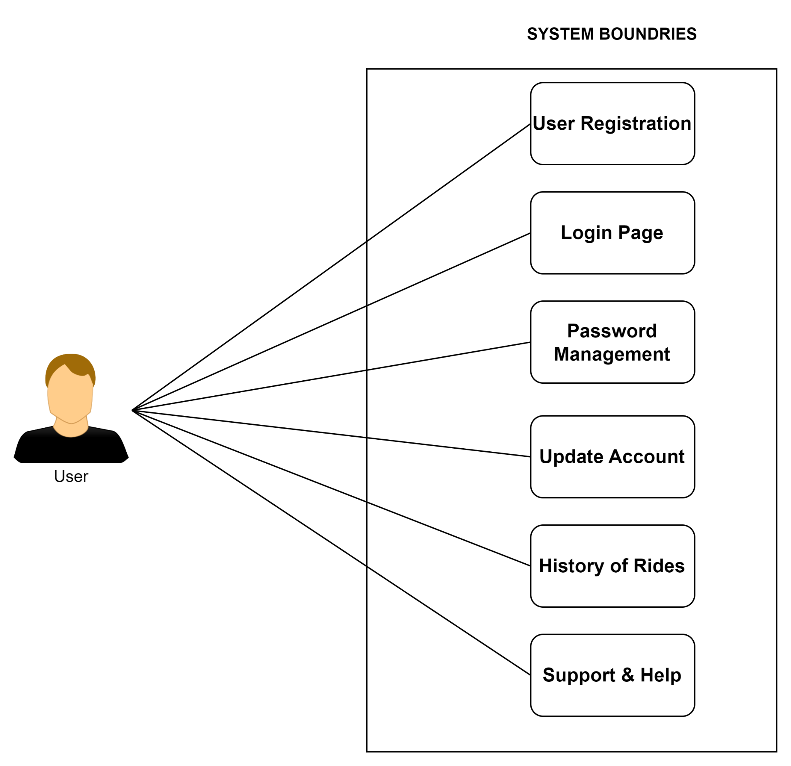

*Fig 2.5.1 User Module Diagram*

#### Driver Module:

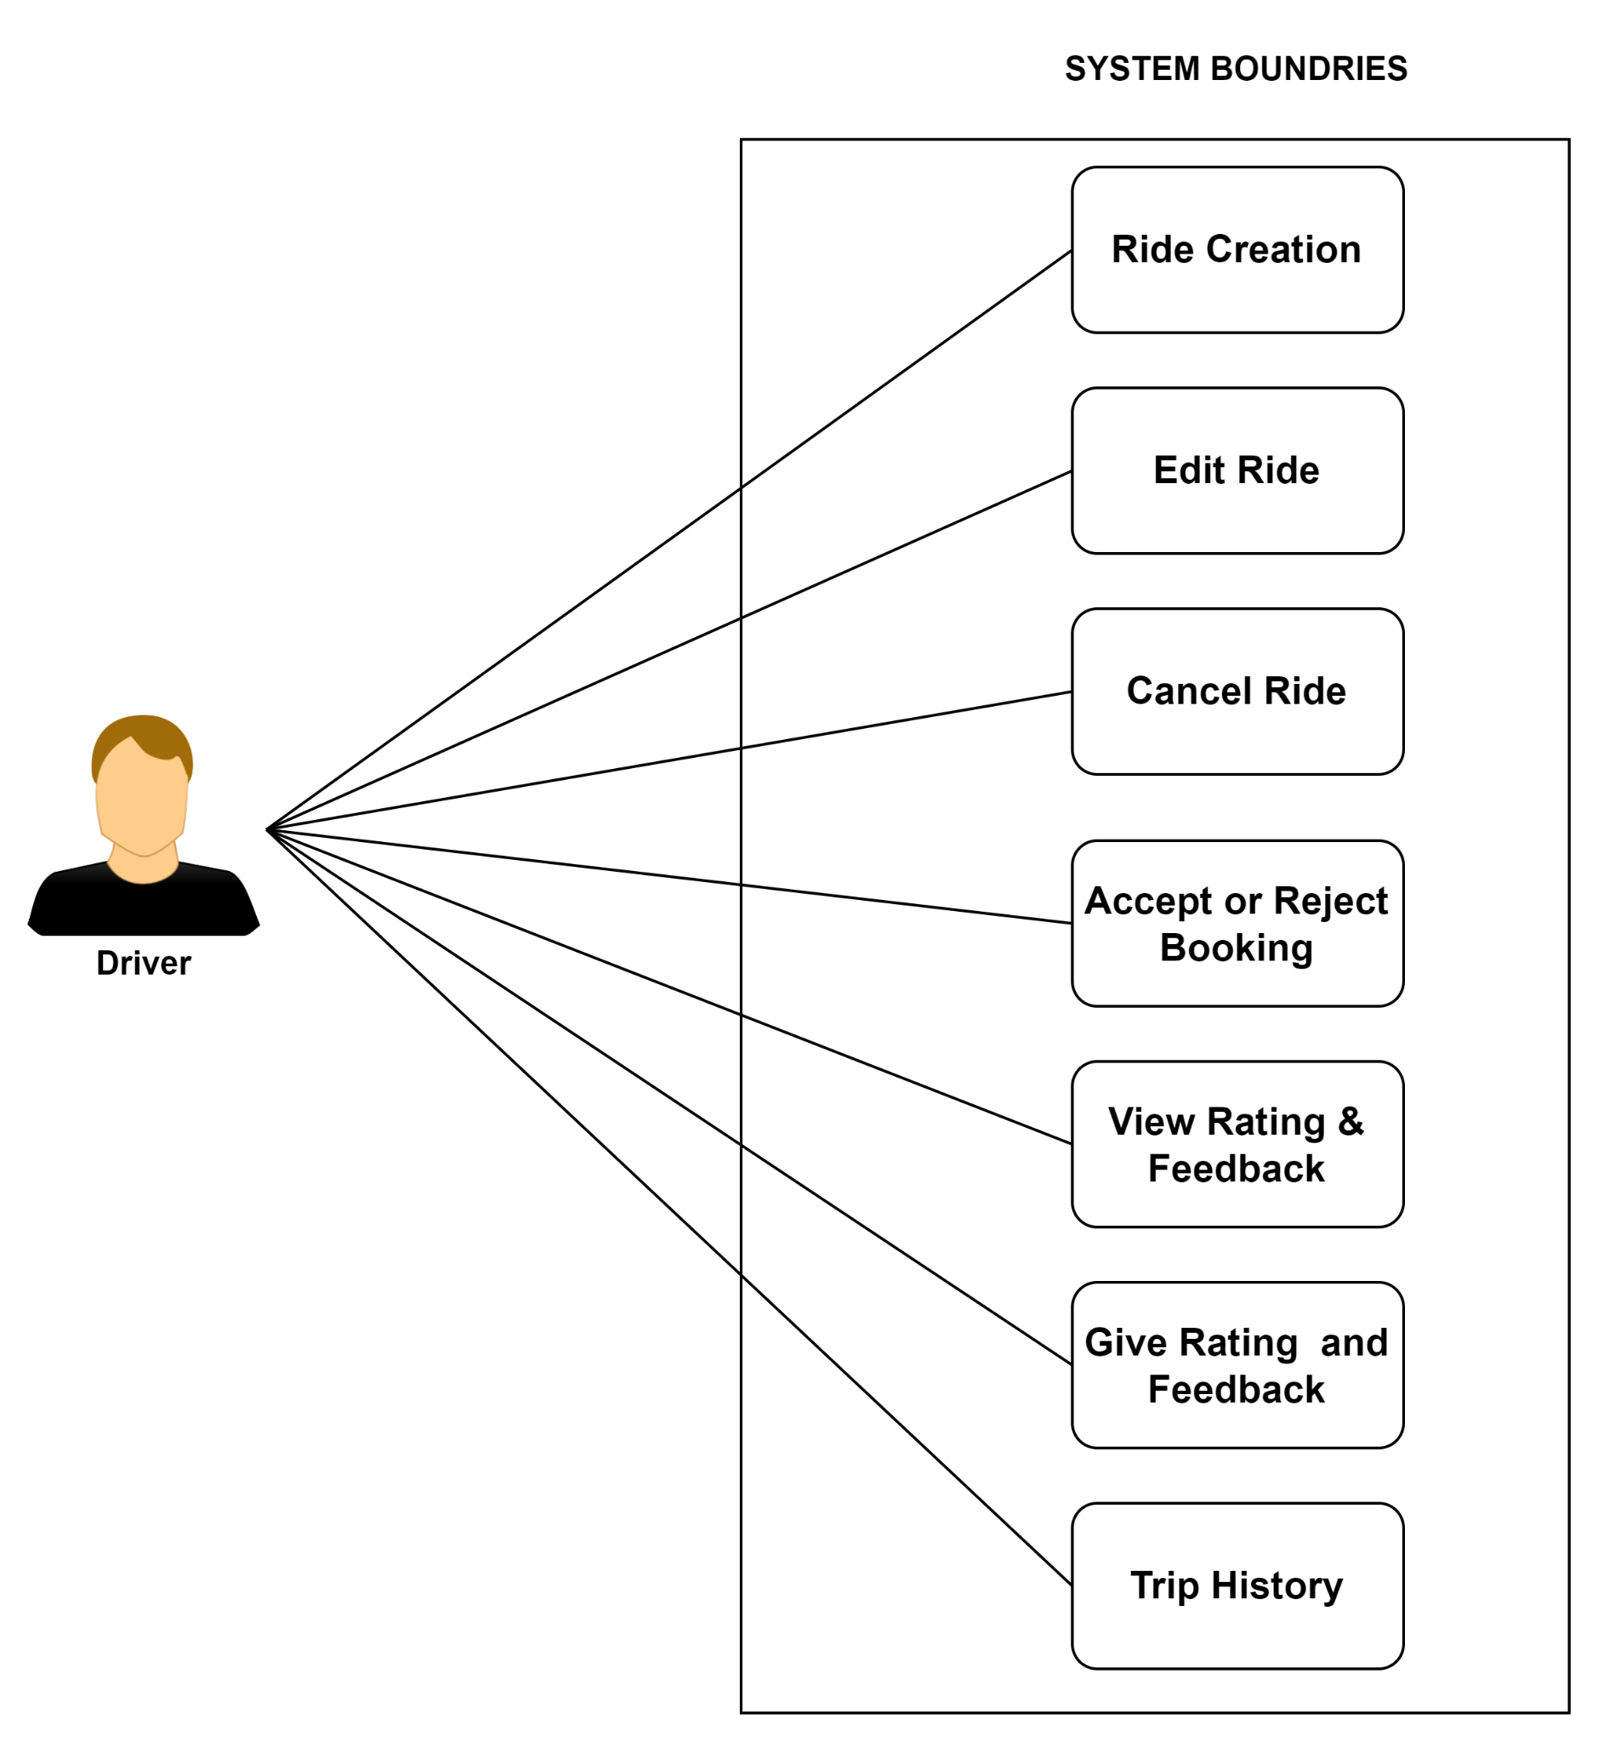

*Fig 2.5.2 Driver Module Diagram*

* 1. *Passenger Module* :

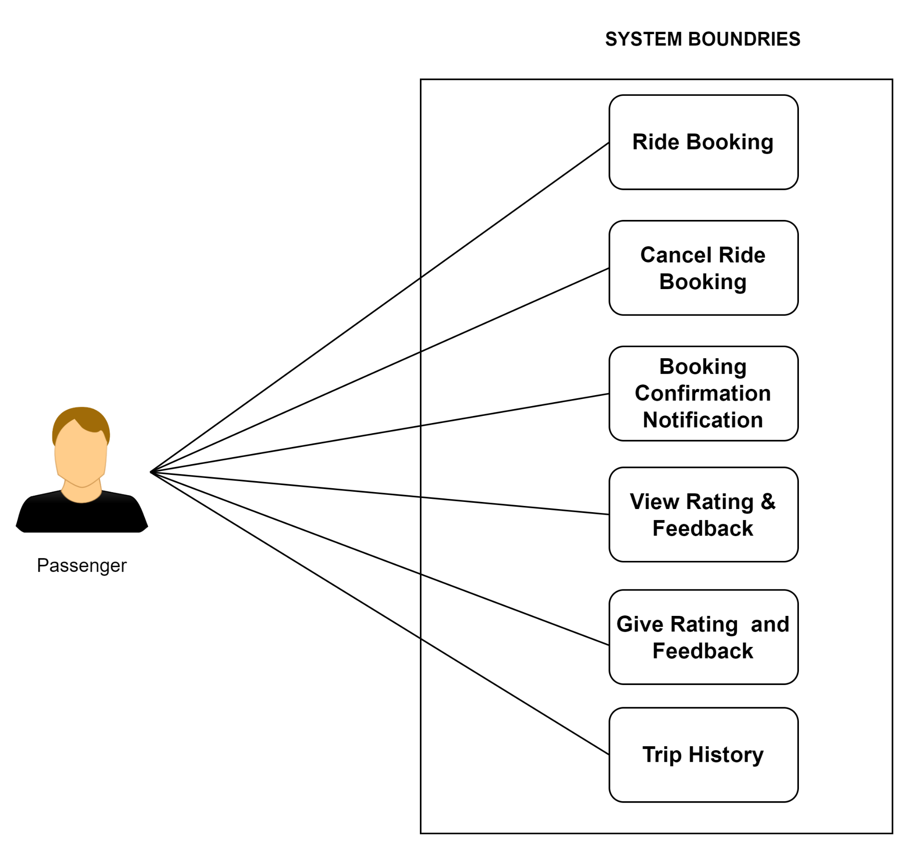

*Fig 2.5.3 Passenger Module Diagram*

* 1. *Admin Module*

